Requirements Validation Document

Team 7 Huehuehue

Manuel Ruiz, Marie Ibrahim, Kyle Bechtel,

Han Htet, Dhruval Darji

REQ-1: The system shall have a visual game board

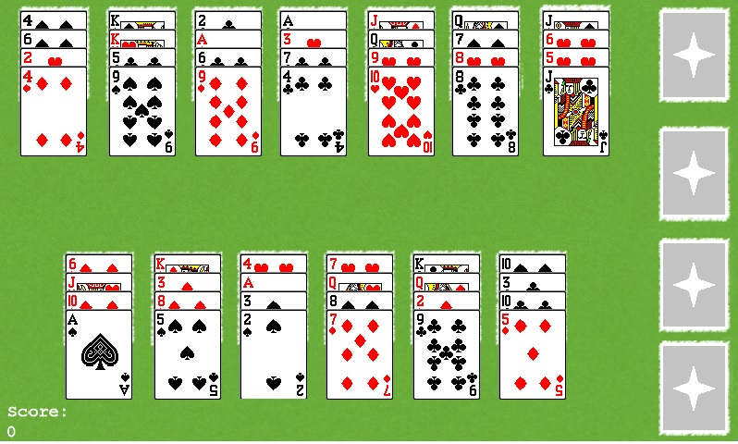

REQ-1.1: The system shall have 13 spots designated for the tableaus

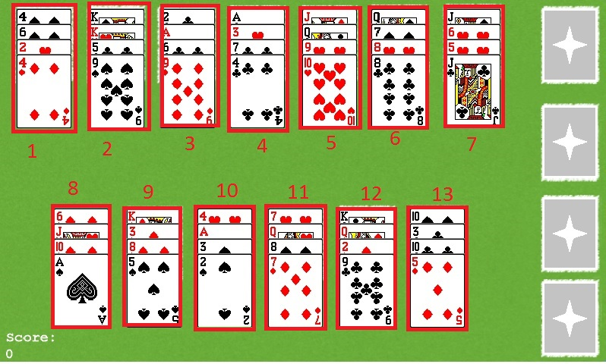

REQ-1.2: The system shall have 4 spots designated for the foundations

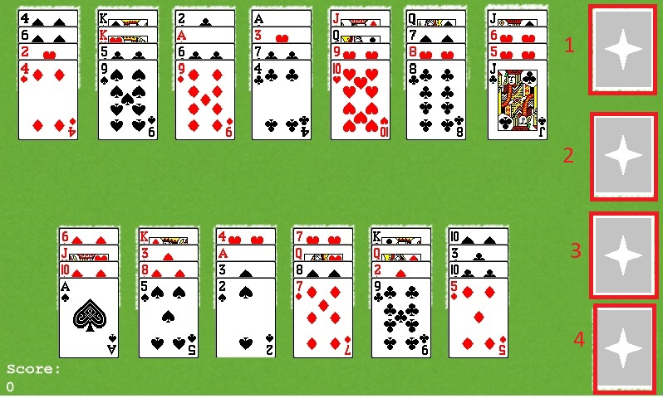

REQ-2: The system shall have 52 visual cards representing the 52 cards of a standard playing deck

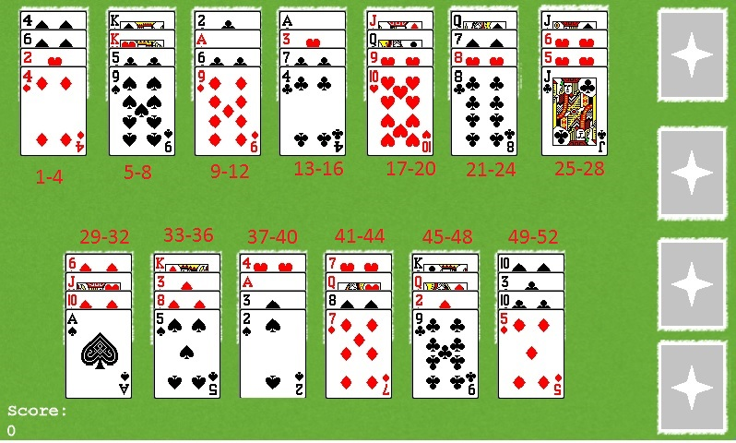

REQ-2.2: The system shall have 4 visual card suits: Club, Spade, Diamond, Heart

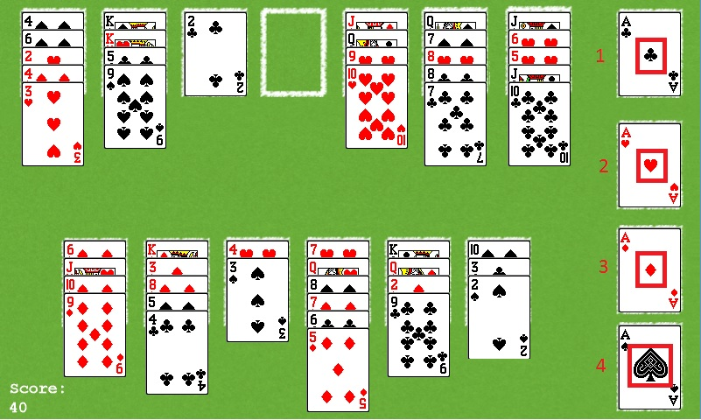

REQ-2.3: The system shall have 13 visual card ranks: (in ascending order) Ace, 2,3,4,5,6,7,8,9,10,J,Q,K

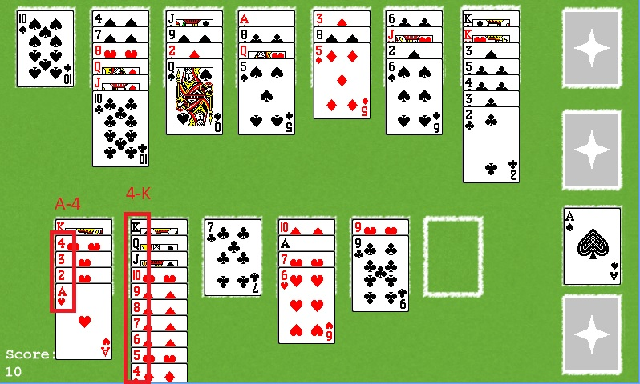

REQ-3: The system shall have mouse input

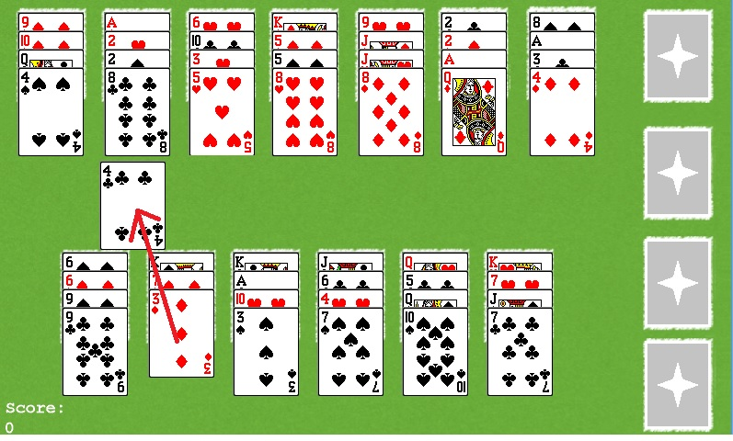

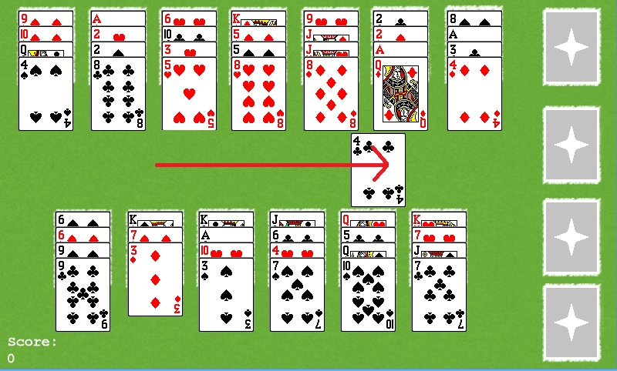

REQ-4: The system shall shuffle 4 cards in each of the tableau spots

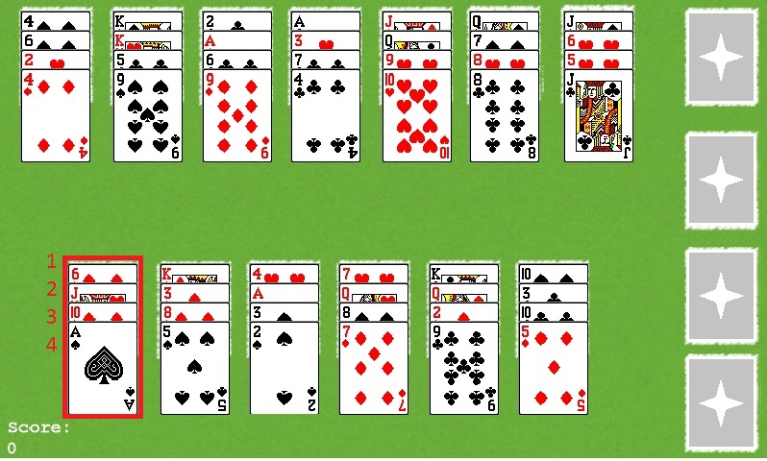

REQ-4.1: The system shall place the Kings at the bottom of their respective piles

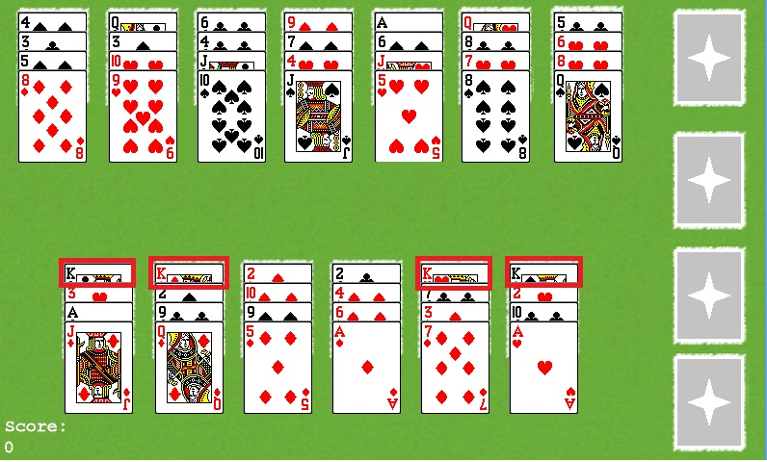

REQ-4.2: The system shall not place 2 kings in the same pile

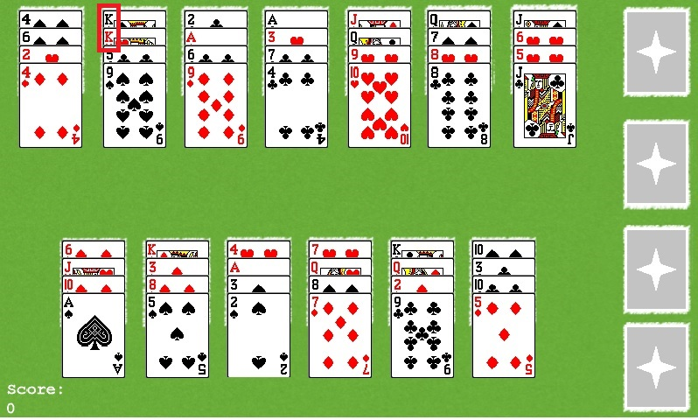

NOTE: In some occasions upon dealing, 2 Kings are placed in the same pile.

REQ-5: They system shall only allow 1 card to be moved at a time

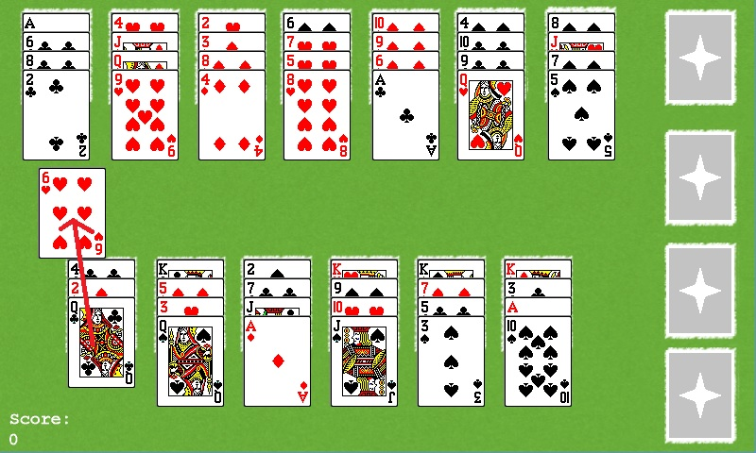

REQ-6: The system shall only allow the top card of each pile to be moved

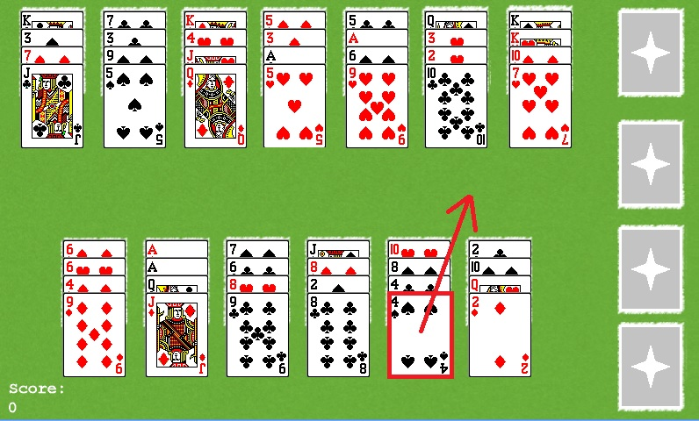

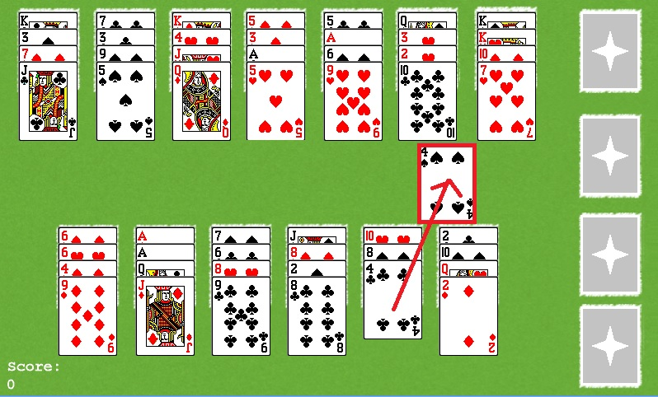

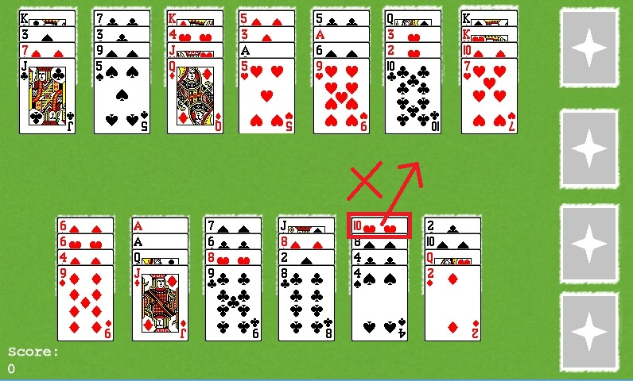

REQ-7: The system shall allow a card to be moved from one pile in the tableau to another pile in the tableau

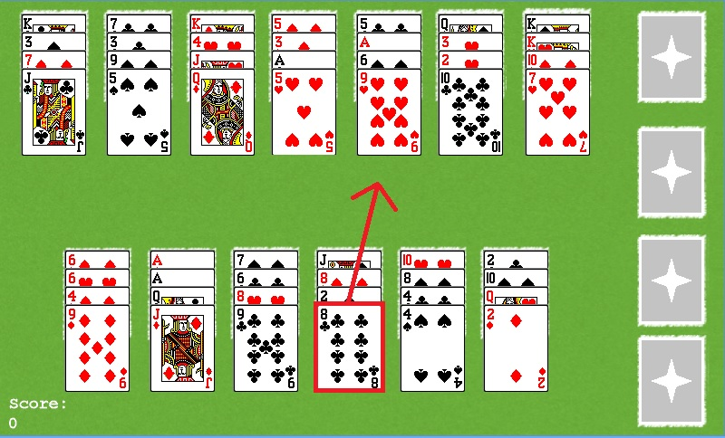

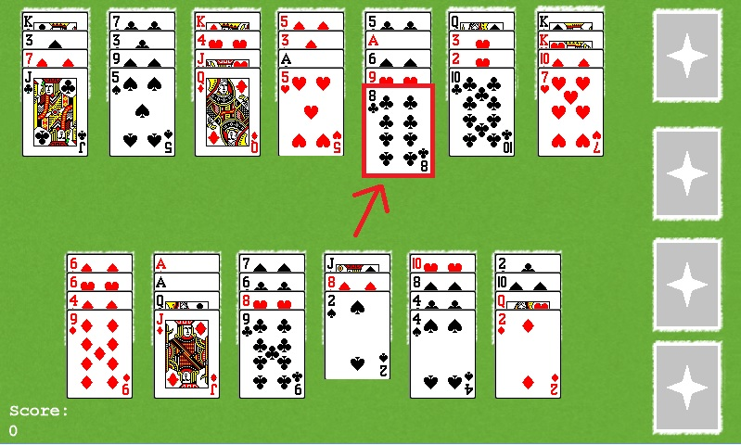

REQ-7.1: The system shall only allow a card to be placed in a pile where the current top card is +1 rank higher than the card being moved.

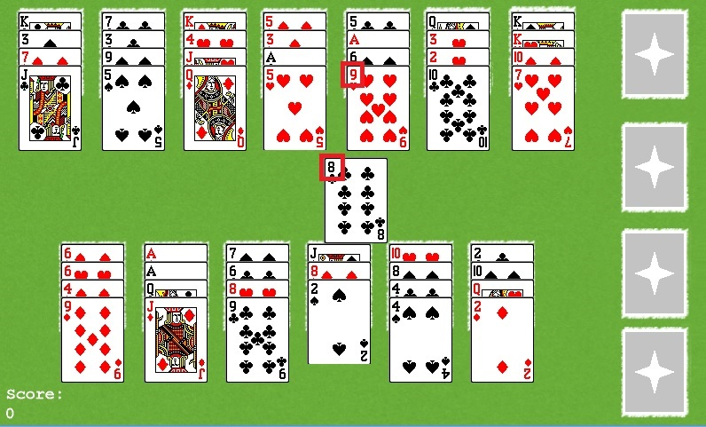

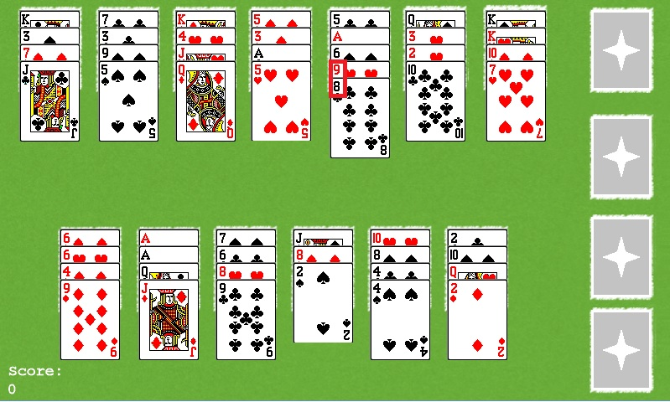

REQ-7.2: The system shall not allow a card to be placed in a pile where the current top card is any rank below the card being moved.

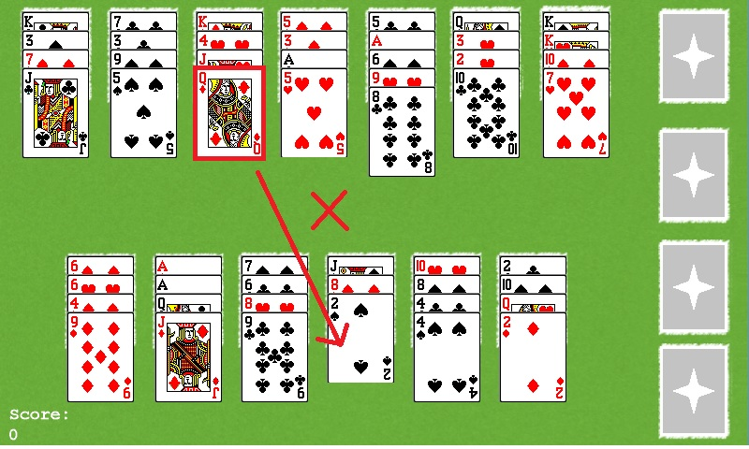

REQ-7.3: The system shall not allow a card to be placed in a pile where the current top card is of the same rank as the card being moved.

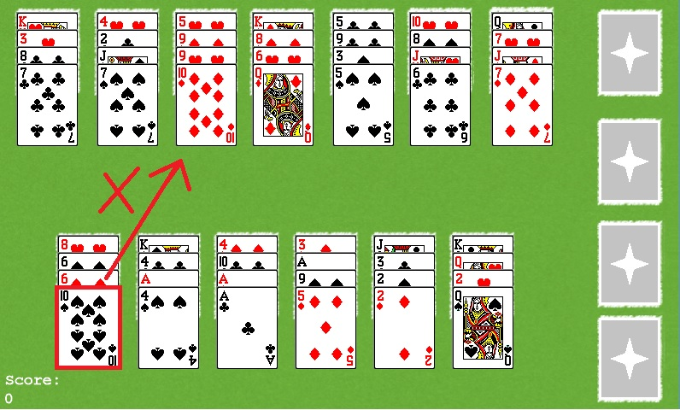

REQ-7.4: The system shall not allow a card to be placed in a pile where the current top card is +2 ranks or more above the card being moved.

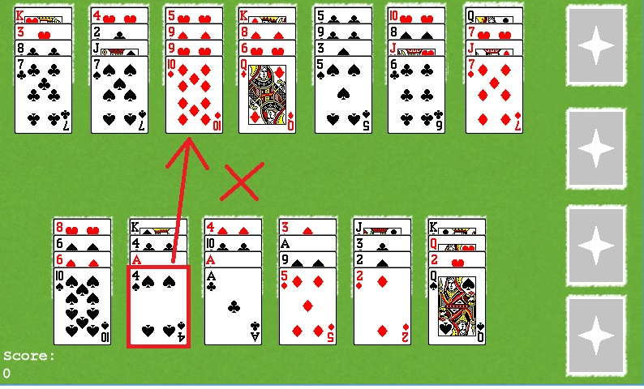

REQ-7.5: The system shall return a card to its originating pile prior to a move if the move is not an acceptable move

REQ-7.5.1: The system shall return a card to its originating pile as the top card

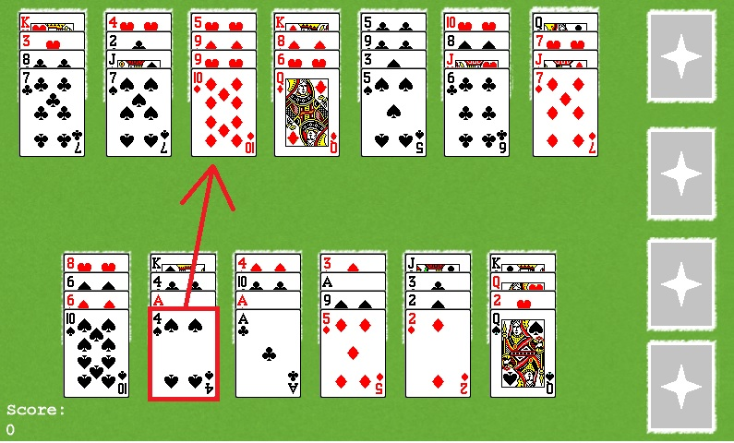

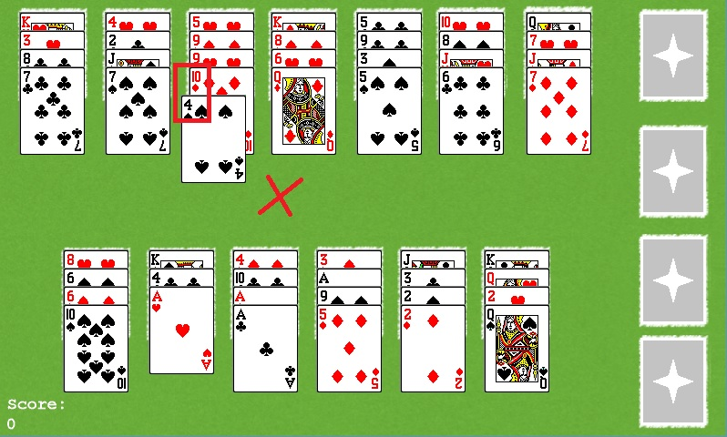

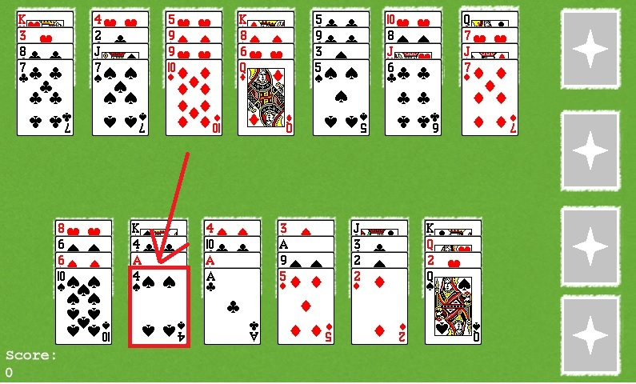

REQ-7.6: The system shall place a card as the new top of the pile if a move is an acceptable move

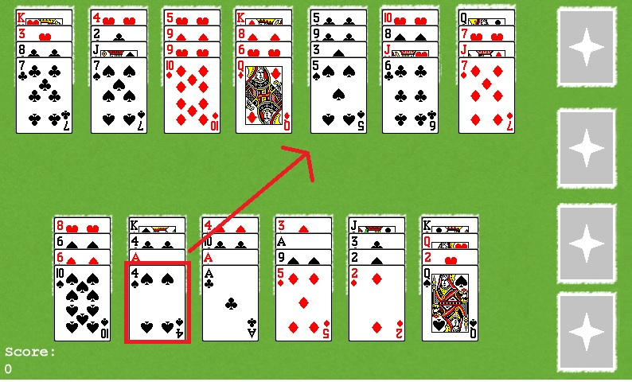

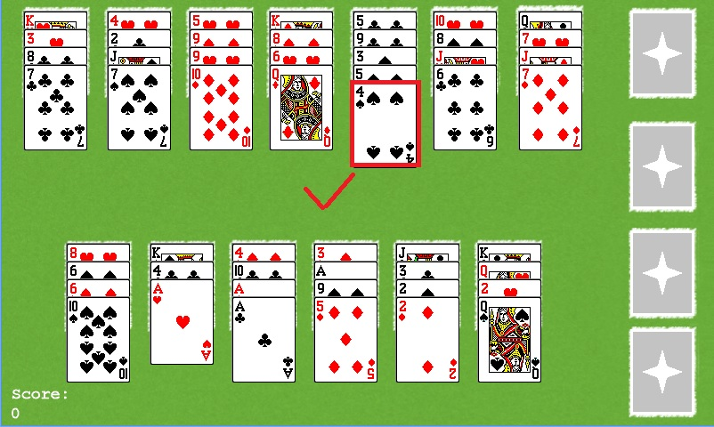

REQ-7.7: The system shall not allow new cards to be placed in a tableau spot once empty

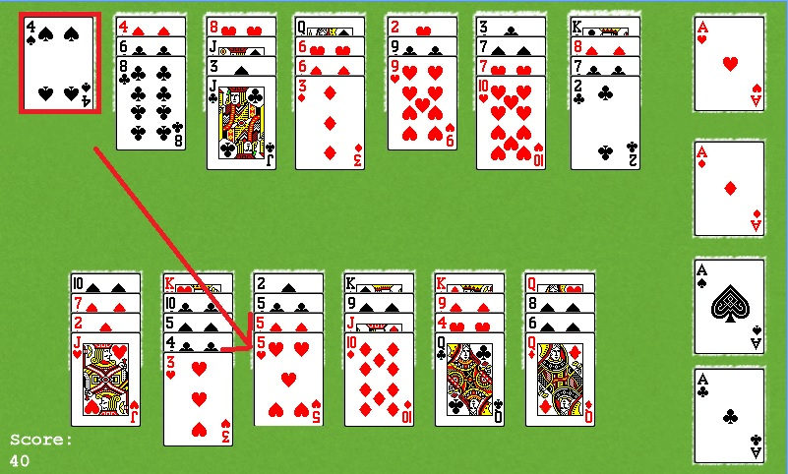

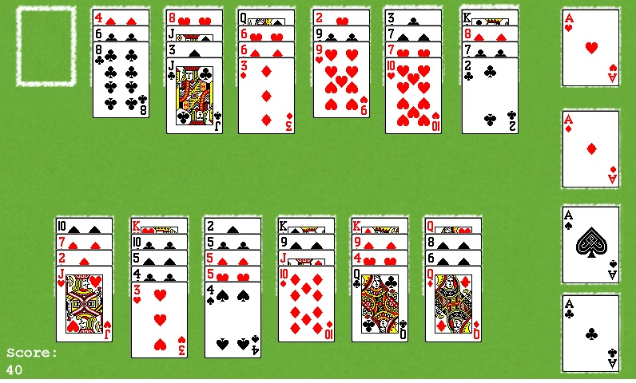

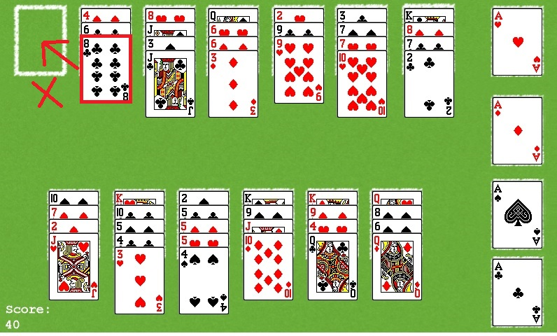

REQ-8: The system shall allow a card to be moved from one pile in the tableau to one pile in the foundation

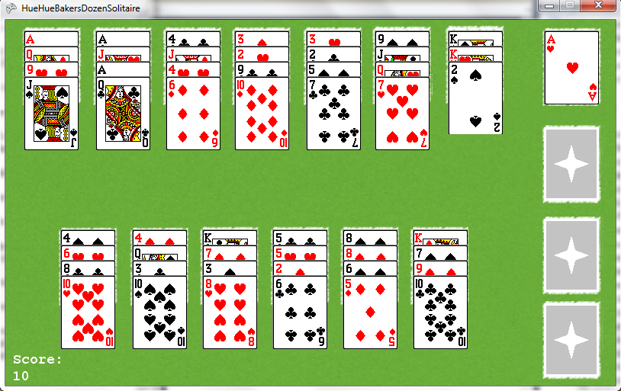

REQ-8.1: The system shall only allow one foundation pile to hold one suit type

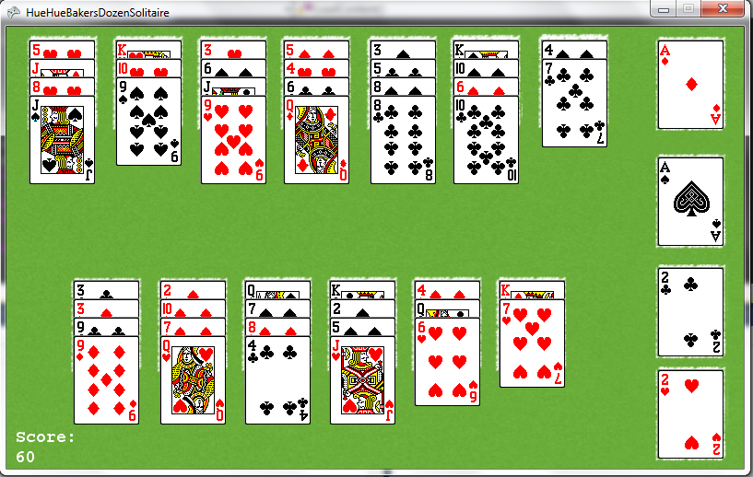

REQ-8.2: The system shall only allow the first card placed in a foundation pile to be an Ace.

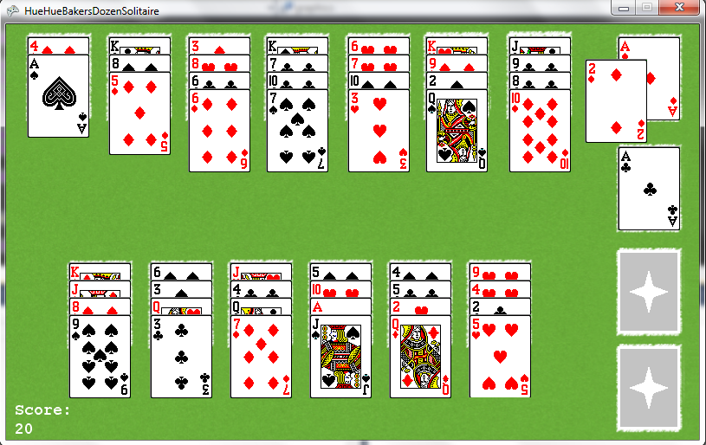

REQ-8.3: The system shall only allow a card placed in the foundation where the current top card is -1 rank of the card being moved.

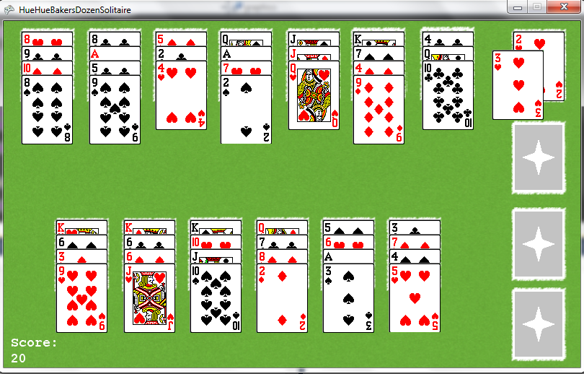

REQ-8.4: The system shall return a card to its originating pile prior to a move if the move is not an acceptable move.

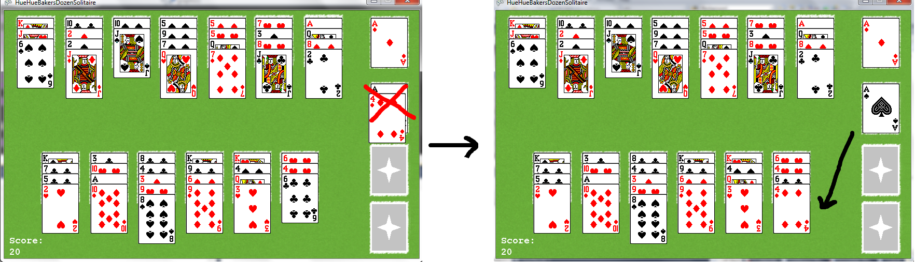

REQ-9: The system shall allow a card to be moved from one pile in the foundation to one pile in the tableau

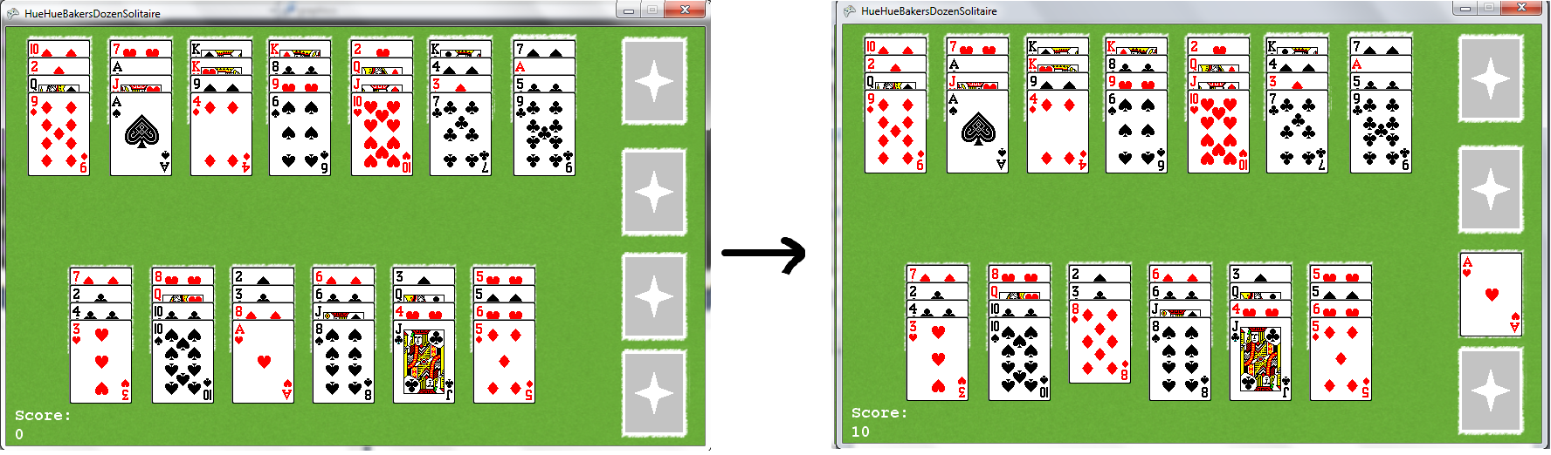

REQ-9.1: The system shall only allow the top card of a foundation pile to be moved.

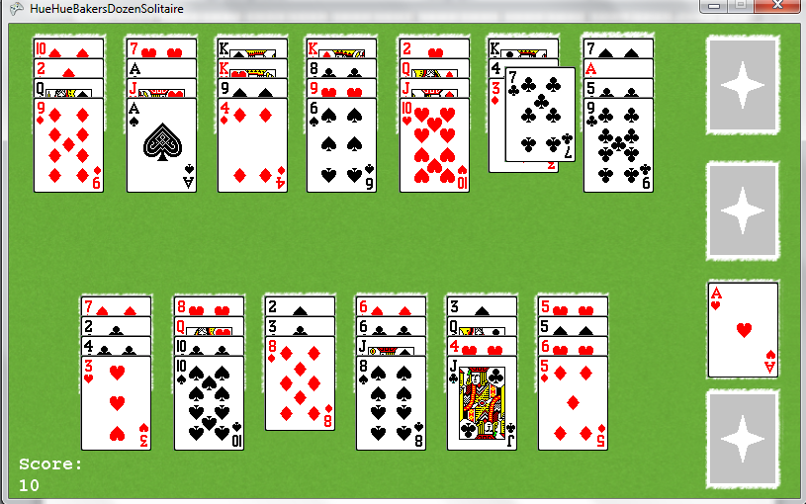

REQ-9.2: The system shall only allow the card to be placed if the current top card of the pile is +1 rank of the card being moved.

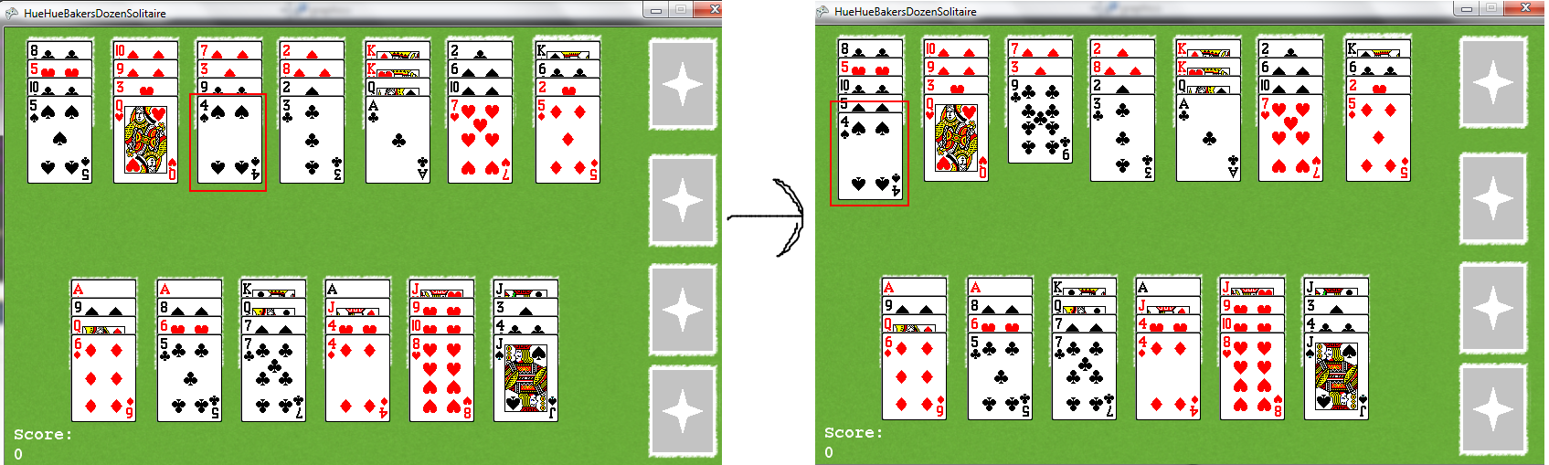

REQ-9.3: The system shall not allow a card to be placed in a pile where the current top card is any rank below the card being moved

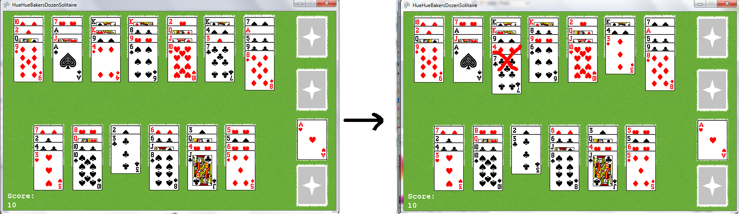

REQ-9.4: The system shall not allow a card to be placed in a pile where the current top card is of the same rank as the card being moved

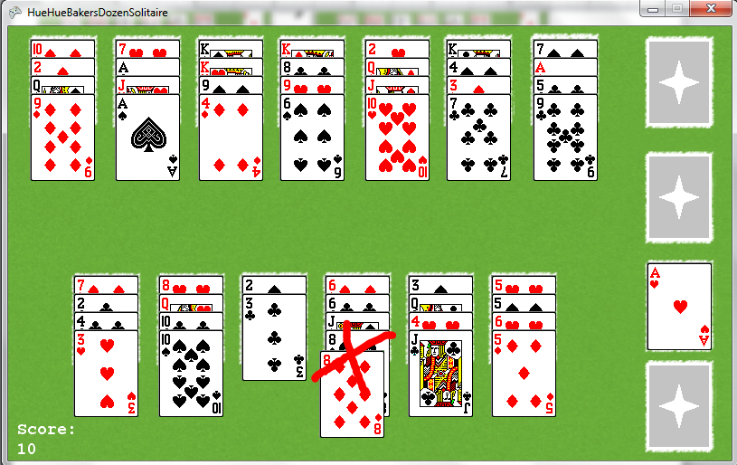

REQ-9.5: The system shall not allow a card to be placed in a pile where the current top card is +2 ranks or more above the card being moved.

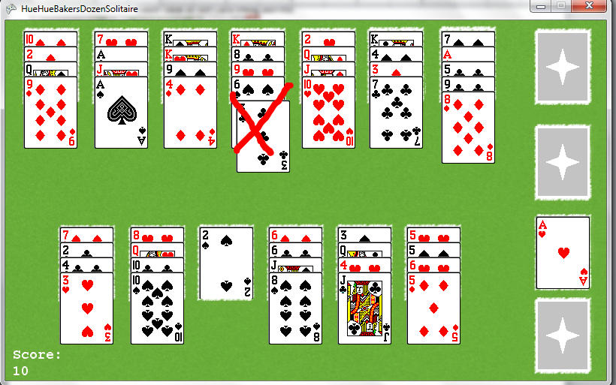

REQ-10: The system shall end the game when all cards are moved from the tableau to the foundation.

